Student Name: | __________________________ |  | Test ID: | 130265018161019
Student Instructions: |  |  | Description: | ECB-8-SS-Unit 3b Statehood
1. | Although the Supreme Court ruled against the state of Georgia in Worcester v. Georgia, why were the Cherokee still relocated to the Indian Territory?

2. | Use the map to answer the question.  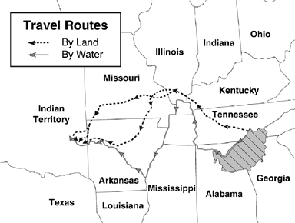  The travel routes on the map indicate the travel paths of which group?
3. | Why did Andrew Jackson’s administration support the removal of Native Americans from the eastern states?

4. | According to the Treaty of Indian Springs, what did the Creek Indians give away?

5. | Which land policy led to the Chattahoochee River becoming Georgia’s western border?
6. | What was the name of the late 1700s program in Georgia that allowed Georgians, for a small fee, to purchase a chance to win unsettled land?

7. | Which tribe in Georgia was MOST affected by the Indian Removal Act?

8. | Which U.S. President signed the Indian Removal Act?
9. | Who was the U.S. Supreme Court Chief Justice in Worcester v. Georgia?

10. | Who helped to challenge the Indian Removal Act in federal court?
11. | To what fate did William McIntosh come after signing the Treaty of Indian Springs?

12. | What is the correct order of Georgia's capitals?
13. | Georgia called for a new state capital to be more?

14. | What device was invented by Eli Whitney to remove seeds from the cotton boll?
15. | How many acres of land were families limited to under the Headright System?

16. | Which system distributed land by matching acre plots with numbered tickets held by potential settlers?
17. | List the effects of the Yazoo Land Act

18. | Which offers the BEST explanation for the Georgia General Assembly's relocation of its capital from Augusta to Louisville in 1796?
19. | What form of transportation led to the growth of Atlanta?

20. | Legislators were bribed to sell land at a very low cost in the

